1. Simple Blog Homepage (HTML Only) - With Descriptive Anchor Text
File: blog-homepage.html
HTML
<!DOCTYPE html><html><head> <title>Foodie Ahmedabad - Best Food & Delivery Tips</title></head><body>
<h1>Foodie Ahmedabad Blog</h1> <p>Latest guides on food delivery, restaurant reviews, and money-saving tips.</p>
<article> <h2>1. Late Night Food Guide</h2> <p>Struggling to find food after 11 PM in Navrangpura?</p> <!-- GOOD Anchor Text: Descriptive, includes keyword --> <a href="/blog/late-night-food-delivery-ahmedabad.html">Best late night food delivery options in Ahmedabad</a> </article>
<article> <h2>2. Biryani Lovers</h2> <p>We tested 10 biryani places this month.</p> <!-- GOOD Anchor Text: Tells user and Google exactly what page is about --> <a href="/blog/best-biryani-restaurants-navrangpura.html">Top 5 best biryani restaurants in Navrangpura - Review</a> </article>
<article> <h2>3. Save Money on Orders</h2> <p>Don't pay full price ever again.</p> <!-- GOOD Anchor Text: Keyword rich --> <a href="/blog/zomato-coupon-codes-2025.html">Latest Zomato coupon codes for 50% OFF first order</a> </article>
</body></html>
Why NOT use 'click here' or 'read more'?
Click here gives zero context to Google. Descriptive anchor like Best late night food delivery options in Ahmedabad tells Google the linked page is about late night delivery in Ahmedabad, helping it rank for that keyword. Also better for screen readers.
2. Silo Structure Diagram for Zomato Food Delivery App
Use this image in your assignment - Ready to upload:
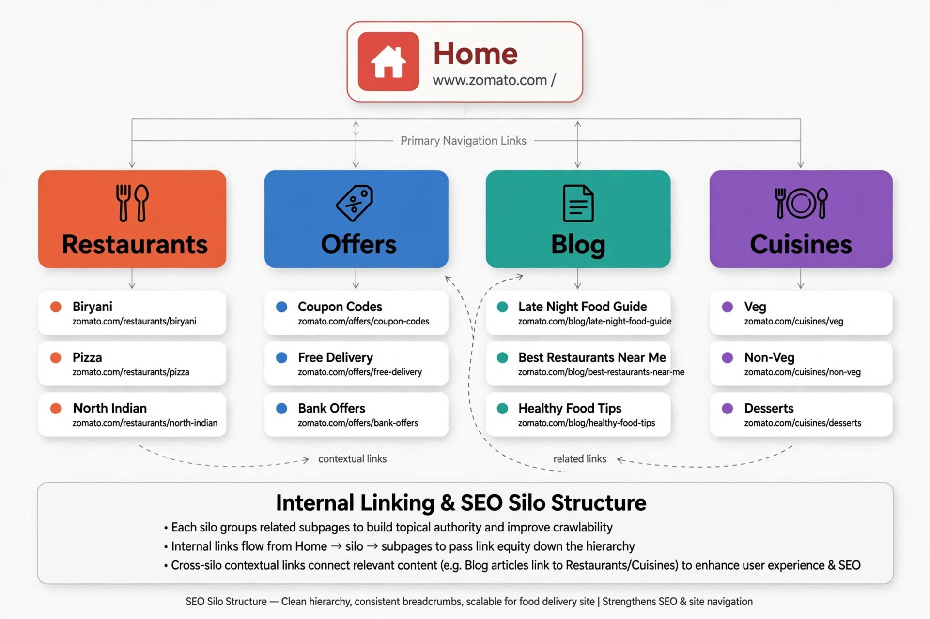

Explanation to write below diagram:
Silo structure groups related pages together to build topical authority.
- Home (www.zomato.com/) links to 4 main silos: Restaurants, Offers, Blog, Cuisines via Primary Navigation - This passes maximum link juice to important categories.
- Each Silo is isolated: Restaurants silo only links to Biryani, Pizza, North Indian. It does NOT link to Bank Offers (which belongs to Offers silo). This keeps topical relevance clean.
- Contextual Cross-Linking: Blog post "Late Night Food Guide" can contextually link to "Biryani" and "Pizza" pages because it's relevant. But we use dotted lines to show these are secondary links, not primary navigation.
- SEO Benefit: Google crawls Home > Silo > Subpage easily. Link equity flows down. Users and bots don't get confused.
3. Rewrite Anchor Text for Flipkart Product Page
Product Page: boAt Airdopes 141
Bad vs Good Anchor Text:
1. Original: 'See more'
Bad because vague, no keyword.
Optimized: View full specifications of boAt Airdopes 141
Why: Includes product name + keyword "specifications" which users search.
2. Original: 'Click here for reviews'
Bad: "Click here" is wasted anchor.
Optimized: Read boAt Airdopes 141 customer reviews and ratings
Why: Keyword rich - targets "boAt Airdopes reviews" - what users search before buying.
3. Original: 'Go to similar products'
Bad: Generic.
Optimized: Compare similar wireless earbuds under 2000
Why: Targets commercial keyword "wireless earbuds under 2000" and helps internal linking to category page.
4. Original: 'Read about returns'
Bad: Doesn't match search intent.
Optimized: Check Flipkart easy 7-day return policy for earbuds
Why: Targets query "Flipkart return policy" and includes trust keyword "easy 7-day return" which increases CTR.
4. BookMyShow Movie Site - Link Juice Priority
Given 6 Internal Links on a Movie Page (e.g., Pushpa 2 Movie Page):
- Home
- Upcoming Movies in Ahmedabad
- BookMyShow Offers - 50% Off
- Pushpa 2 Cast & Crew (Allu Arjun Filmography)
- Privacy Policy
- Book Pushpa 2 Tickets in Ahmedabad
Which 2 Pages Should Receive Most Link Juice?
Answer: Pages #2 and #6
Why?
- #6 Book Pushpa 2 Tickets in Ahmedabad - This is the MONEY page - transactional, BOFU. This page generates revenue. It should get most internal links from all movie pages, blog posts, homepage. This is where user converts.
- #2 Upcoming Movies in Ahmedabad - This is category/hub page that needs to rank for "movies in Ahmedabad" (high volume). It passes link juice to all individual movie pages.
Which pages should get LEAST juice?
Privacy Policy (#5) - No SEO value, should be nofollow or linked only in footer.
How to Adjust Internal Linking:
- Add contextual link in movie description: "Looking for more options? Check upcoming movies in Ahmedabad" - links to #2
- Add sticky CTA button: "Book Pushpa 2 tickets at lowest price" at top and bottom linking to #6 - passes max juice
- Add breadcrumb: Home > Movies in Ahmedabad > Pushpa 2 - This internally links to #2
- Remove link juice from Privacy Policy by adding rel="nofollow" or keeping it only in footer, not in main content.
5. Topic Cluster for Spotify Music App - Pillar-Cluster Model
Topic Chosen: Lofi Music
Pillar Page (Main Hub - 3000 words, broad keyword):
URL: spotify.com/lofi-music/
Title: The Ultimate Guide to Lofi Music: Best Playlists, Artists & Benefits for Focus
Target Keyword: lofi music (Volume 90K)
This page covers everything briefly: What is lofi, history, benefits, top artists, how to create playlist.
3 Cluster Pages (Sub-topics - 800 words each, long-tail keywords) - Link to Pillar:
Cluster 1: spotify.com/lofi-music/study-playlist/
Title: Best Lofi Study Playlist for Students - 24/7 Focus Beats
Keyword: lofi study playlist
Linking: Cluster 1 -> Links to Pillar with anchor "back to complete lofi music guide" AND Pillar links to Cluster 1 with anchor "best lofi playlist for studying"
Cluster 2: spotify.com/lofi-music/sleep-music/
Title: Lofi Sleep Music - Chill Beats to Help You Sleep Faster
Keyword: lofi sleep music
Linking: Cluster 2 -> Links to Pillar + Links to Cluster 1 (related) with anchor "try our lofi study playlist too"
Cluster 3: spotify.com/lofi-music/how-to-make-lofi/
Title: How to Make Lofi Music at Home - Free Tools & Tutorial
Keyword: how to make lofi music
Linking: Cluster 3 -> Links to Pillar with anchor "explore more lofi music on Spotify"
Pillar-Cluster Model Diagram:
Code
Pillar Page (lofi music) ^ | ^ | v |Cluster 1 <-> Cluster 2 ^ | |_______v Cluster 3
All Clusters link UP to Pillar (passes authority up)Pillar links DOWN to all Clusters (passes link juice down, distributes ranking)Clusters interlink with each other (keeps user on site, topical relevance)
6 lines hidden
SEO Benefit: This builds topical authority. Google sees Spotify covers "lofi music" comprehensively, so pillar ranks for competitive term "lofi music" and clusters rank for long-tail terms, all supporting each other.

